SWEN2 Practicum week 3.

Opdracht grenswaarde analyse:

De code die ik hiervoor is:

if(inviteModel.checkInvitation(gameController.getC_login().getUsername(), invitePane.getName1().getText()) <= 0) {

if(inviteModel.checkInvitation(gameController.getC_login().getUsername(), invitePane.getName2().getText()) <=0) {

if(inviteModel.checkInvitation(gameController.getC_login().getUsername(), invitePane.getName3().getText()) <= 0) {

Deze code staat op 65 van de InviteController.java class.

|  |  |  |  |
| --- | --- | --- | --- |
|  | -1 | 0 | 1 |
| Invitemodel.checkInvitation ==1 | 0 | 0 | 1 |
| Invitemodel.checkinvitation > 0 | 0 | 0 | 1 |
| Invitemodel.checkinvitation > = 0 | 0 | 1 | 1 |
| Invitemodel.checkinvitaion !=0 | 1 | 0 | 1 |
| Invitemodel.checkinvitation !=1 | 1 | 1 | 0 |
| Invitemodel.checkinvitation < = 0 | 1 | 1 | 0 |
| Invitemodel.checkinvitaion == 0 | 0 | 1 | 0 |
| Lichte variant |  | x | x |
| Normale variant | x | x | x |

Opdracht pairwise testing.

De code die ik hiervoor gebruik:

if (!username1.equals(username2) && !username1.equals(username3) && !username2.equals(username3)) {

|  |  |  |
| --- | --- | --- |
| Username1 | Username2 | Uitkomst |
| 0 | 0 | 0 |
| 1 | 0 | 0 |
| 0 | 1 | 0 |
| 1 | 1 | 1 |

Deze code komt uit de package controller: invitecontroller.java class en staat op regel 217.

Opdracht procescyclus testen:

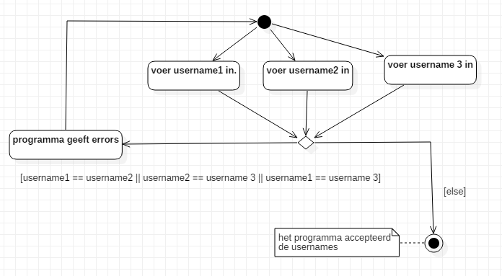

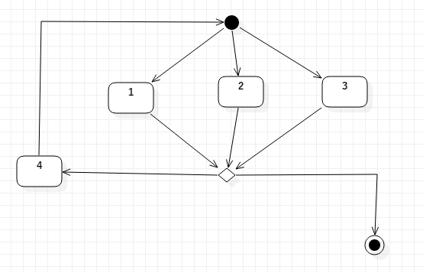

|  |  |  |  |
| --- | --- | --- | --- |
| Knooppunt | Inkomend | Uitgaand | Combinaties |
| Decision | 1,2,3 | 4 | 1-4,2-4,3-4 |
| 4 | Decision | Initial start. | Decision-initial start |
| Decision | 1,2,3 | final | 1-final,2-final,3-final |